Firewall Tutorial
Nowadays, it is a big challenge to protect our sensitive data from unwanted and unauthorized sources. There are various tools and devices that can provide different security levels and help keep our private data secure. One such tool is a 'firewall' that prevents unauthorized access and keeps our computers and data safe and secure.
In this article, we have talked about firewalls as well as other related topics, such as why we need firewalls, functions of firewalls, limitations of firewalls, working of firewalls, etc.

What is a Firewall?
A firewall can be defined as a special type of network security device or a software program that monitors and filters incoming and outgoing network traffic based on a defined set of security rules. It acts as a barrier between internal private networks and external sources (such as the public Internet).
The primary purpose of a firewall is to allow non-threatening traffic and prevent malicious or unwanted data traffic for protecting the computer from viruses and attacks. A firewall is a cybersecurity tool that filters network traffic and helps users block malicious software from accessing the Internet in infected computers.
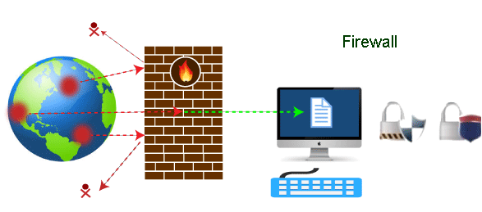

Firewall: Hardware or Software
This is one of the most problematic questions whether a firewall is a hardware or software. As stated above, a firewall can be a network security device or a software program on a computer. This means that the firewall comes at both levels, i.e., hardware and software, though it's best to have both.
Each format (a firewall implemented as hardware or software) has different functionality but the same purpose. A hardware firewall is a physical device that attaches between a computer network and a gateway. For example, a broadband router. On the other hand, a software firewall is a simple program installed on a computer that works through port numbers and other installed software.
Apart from that, there are cloud-based firewalls. They are commonly referred to as FaaS (firewall as a service). A primary advantage of using cloud-based firewalls is that they can be managed centrally. Like hardware firewalls, cloud-based firewalls are best known for providing perimeter security.

Why Firewall
Firewalls are primarily used to prevent malware and network-based attacks. Additionally, they can help in blocking application-layer attacks. These firewalls act as a gatekeeper or a barrier. They monitor every attempt between our computer and another network. They do not allow data packets to be transferred through them unless the data is coming or going from a user-specified trusted source.
Firewalls are designed in such a way that they can react quickly to detect and counter-attacks throughout the network. They can work with rules configured to protect the network and perform quick assessments to find any suspicious activity. In short, we can point to the firewall as a traffic controller.
Some of the important risks of not having a firewall are:

Open Access
If a computer is running without a firewall, it is giving open access to other networks. This means that it is accepting every kind of connection that comes through someone. In this case, it is not possible to detect threats or attacks coming through our network. Without a firewall, we make our devices vulnerable to malicious users and other unwanted sources.

Lost or Comprised Data
Without a firewall, we are leaving our devices accessible to everyone. This means that anyone can access our device and have complete control over it, including the network. In this case, cybercriminals can easily delete our data or use our personal information for their benefit.

Network Crashes
In the absence of a firewall, anyone could access our network and shut it down. It may lead us to invest our valuable time and money to get our network working again.
Therefore, it is essential to use firewalls and keep our network, computer, and data safe and secure from unwanted sources.

Brief History of Firewall
Firewalls have been the first and most reliable component of defense in network security for over 30 years. Firewalls first came into existence in the late 1980s. They were initially designed as packet filters. These packet filters were nothing but a setup of networks between computers. The primary function of these packet filtering firewalls was to check for packets or bytes transferred between different computers.
Firewalls have become more advanced due to continuous development, although such packet filtering firewalls are still in use in legacy systems.
As the technology emerged, Gil Shwed from Check Point Technologies introduced the first stateful inspection firewall in 1993. It was named as FireWall-1. Back in 2000, Netscreen came up with its purpose-built firewall 'Appliance'. It gained popularity and fast adoption within enterprises because of increased internet speed, less latency, and high throughput at a lower cost.
The turn of the century saw a new approach to firewall implementation during the mid-2010. The 'Next-Generation Firewalls' were introduced by the Palo Alto Networks. These firewalls came up with a variety of built-in functions and capabilities, such as Hybrid Cloud Support, Network Threat Prevention, Application and Identity-Based Control, and Scalable Performance, etc. Firewalls are still getting new features as part of continuous development. They are considered the first line of defense when it comes to network security.

How does a firewall work?
A firewall system analyzes network traffic based on pre-defined rules. It then filters the traffic and prevents any such traffic coming from unreliable or suspicious sources. It only allows incoming traffic that is configured to accept.
Typically, firewalls intercept network traffic at a computer's entry point, known as a port. Firewalls perform this task by allowing or blocking specific data packets (units of communication transferred over a digital network) based on pre-defined security rules. Incoming traffic is allowed only through trusted IP addresses, or sources.
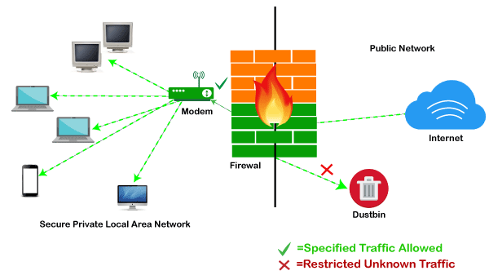

Functions of Firewall
As stated above, the firewall works as a gatekeeper. It analyzes every attempt coming to gain access to our operating system and prevents traffic from unwanted or non-recognized sources.
Since the firewall acts as a barrier or filter between the computer system and other networks (i.e., the public Internet), we can consider it as a traffic controller. Therefore, a firewall's primary function is to secure our network and information by controlling network traffic, preventing unwanted incoming network traffic, and validating access by assessing network traffic for malicious things such as hackers and malware.
Generally, most operating systems (for example - Windows OS) and security software come with built-in firewall support. Therefore, it is a good idea to ensure that those options are turned on. Additionally, we can configure the security settings of the system to be automatically updated whenever available.
Firewalls have become so powerful, and include a variety of functions and capabilities with built-in features:
- Network Threat Prevention
- Application and Identity-Based Control
- Hybrid Cloud Support
- Scalable Performance
- Network Traffic Management and Control
- Access Validation
- Record and Report on Events

Limitations of Firewall
When it comes to network security, firewalls are considered the first line of defense. But the question is whether these firewalls are strong enough to make our devices safe from cyber-attacks. The answer may be "no". The best practice is to use a firewall system when using the Internet. However, it is important to use other defense systems to help protect the network and data stored on the computer. Because cyber threats are continually evolving, a firewall should not be the only consideration for protecting the home network.
The importance of using firewalls as a security system is obvious; however, firewalls have some limitations:
- Firewalls cannot stop users from accessing malicious websites, making it vulnerable to internal threats or attacks.
- Firewalls cannot protect against the transfer of virus-infected files or software.
- Firewalls cannot prevent misuse of passwords.
- Firewalls cannot protect if security rules are misconfigured.
- Firewalls cannot protect against non-technical security risks, such as social engineering.
- Firewalls cannot stop or prevent attackers with modems from dialing in to or out of the internal network.
- Firewalls cannot secure the system which is already infected.
Therefore, it is recommended to keep all Internet-enabled devices updated. This includes the latest operating systems, web browsers, applications, and other security software (such as anti-virus). Besides, the security of wireless routers should be another practice. The process of protecting a router may include options such as repeatedly changing the router's name and password, reviewing security settings, and creating a guest network for visitors.

Types of Firewall
Depending on their structure and functionality, there are different types of firewalls. The following is a list of some common types of firewalls:
- Proxy Firewall
- Packet-filtering firewalls
- Stateful Multi-layer Inspection (SMLI) Firewall
- Unified threat management (UTM) firewall
- Next-generation firewall (NGFW)
- Network address translation (NAT) firewalls

Difference between a Firewall and Anti-virus
Firewalls and anti-viruses are systems to protect devices from viruses and other types of Trojans, but there are significant differences between them. Based on the vulnerabilities, the main differences between firewalls and anti-viruses are tabulated below:
Attributes | Firewall | Anti-virus
Definition | A firewall is defined as the system which analyzes and filters incoming or outgoing data packets based on pre-defined rules. | Anti-virus is defined as the special type of software that acts as a cyber-security mechanism. The primary function of Anti-virus is to monitor, detect, and remove any apprehensive or distrustful file or software from the device.
Structure | Firewalls can be hardware and software both. The router is an example of a physical firewall, and a simple firewall program on the system is an example of a software firewall. | Anti-virus can only be used as software. Anti-virus is a program that is installed on the device, just like the other programs.
Implementation | Because firewalls come in the form of hardware and software, a firewall can be implemented either way. | Because Anti-virus comes in the form of software, therefore, Anti-virus can be implemented only at the software level. There is no possibility of implementing Anti-virus at the hardware level.
Responsibility | A firewall is usually defined as a network controlling system. It means that firewalls are primarily responsible for monitoring and filtering network traffic. | Anti-viruses are primarily responsible for detecting and removing viruses from computer systems or other devices. These viruses can be in the form of infected files or software.
Scalability | Because the firewall supports both types of implementations, hardware, and software, therefore, it is more scalable than anti-virus. | Anti-viruses are generally considered less-scalable than firewalls. This is because anti-virus can only be implemented at the software level. They don't support hardware-level implementation.
Threats | A firewall is mainly used to prevent network related attacks. It mainly includes external network threats?for example- Routing attacks and IP Spoofing. | Anti-virus is mainly used to scan, find, and remove viruses, malware, and Trojans, which can harm system files and software and share personal information (such as login credentials, credit card details, etc.) with hackers.

Types of Firewall
There are mainly three types of firewalls, such as software firewalls, hardware firewalls, or both, depending on their structure. Each type of firewall has different functionality but the same purpose. However, it is best practice to have both to achieve maximum possible protection.
A hardware firewall is a physical device that attaches between a computer network and a gateway. For example- a broadband router. A hardware firewall is sometimes referred to as an Appliance Firewall. On the other hand, a software firewall is a simple program installed on a computer that works through port numbers and other installed software. This type of firewall is also called a Host Firewall.
Besides, there are many other types of firewalls depending on their features and the level of security they provide. The following are types of firewall techniques that can be implemented as software or hardware:
- Packet-filtering Firewalls
- Circuit-level Gateways
- Application-level Gateways (Proxy Firewalls)
- Stateful Multi-layer Inspection (SMLI) Firewalls
- Next-generation Firewalls (NGFW)
- Threat-focused NGFW
- Network Address Translation (NAT) Firewalls
- Cloud Firewalls
- Unified Threat Management (UTM) Firewalls
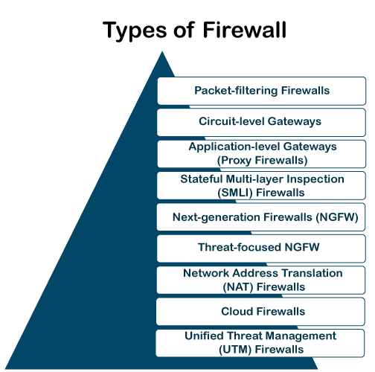

Packet-filtering Firewalls
A packet filtering firewall is the most basic type of firewall. It acts like a management program that monitors network traffic and filters incoming packets based on configured security rules. These firewalls are designed to block network traffic IP protocols, an IP address, and a port number if a data packet does not match the established rule-set.
While packet-filtering firewalls can be considered a fast solution without many resource requirements, they also have some limitations. Because these types of firewalls do not prevent web-based attacks, they are not the safest.

Circuit-level Gateways
Circuit-level gateways are another simplified type of firewall that can be easily configured to allow or block traffic without consuming significant computing resources. These types of firewalls typically operate at the session-level of the OSI model by verifying TCP (Transmission Control Protocol) connections and sessions. Circuit-level gateways are designed to ensure that the established sessions are protected.
Typically, circuit-level firewalls are implemented as security software or pre-existing firewalls. Like packet-filtering firewalls, these firewalls do not check for actual data, although they inspect information about transactions. Therefore, if a data contains malware, but follows the correct TCP connection, it will pass through the gateway. That is why circuit-level gateways are not considered safe enough to protect our systems.

Application-level Gateways (Proxy Firewalls)
Proxy firewalls operate at the application layer as an intermediate device to filter incoming traffic between two end systems (e.g., network and traffic systems). That is why these firewalls are called 'Application-level Gateways'.
Unlike basic firewalls, these firewalls transfer requests from clients pretending to be original clients on the web-server. This protects the client's identity and other suspicious information, keeping the network safe from potential attacks. Once the connection is established, the proxy firewall inspects data packets coming from the source. If the contents of the incoming data packet are protected, the proxy firewall transfers it to the client. This approach creates an additional layer of security between the client and many different sources on the network.

Stateful Multi-layer Inspection (SMLI) Firewalls
Stateful multi-layer inspection firewalls include both packet inspection technology and TCP handshake verification, making SMLI firewalls superior to packet-filtering firewalls or circuit-level gateways. Additionally, these types of firewalls keep track of the status of established connections.
In simple words, when a user establishes a connection and requests data, the SMLI firewall creates a database (state table). The database is used to store session information such as source IP address, port number, destination IP address, destination port number, etc. Connection information is stored for each session in the state table. Using stateful inspection technology, these firewalls create security rules to allow anticipated traffic.
In most cases, SMLI firewalls are implemented as additional security levels. These types of firewalls implement more checks and are considered more secure than stateless firewalls. This is why stateful packet inspection is implemented along with many other firewalls to track statistics for all internal traffic. Doing so increases the load and puts more pressure on computing resources. This can give rise to a slower transfer rate for data packets than other solutions.

Next-generation Firewalls (NGFW)
Many of the latest released firewalls are usually defined as 'next-generation firewalls'. However, there is no specific definition for next-generation firewalls. This type of firewall is usually defined as a security device combining the features and functionalities of other firewalls. These firewalls include deep-packet inspection (DPI), surface-level packet inspection, and TCP handshake testing, etc.
NGFW includes higher levels of security than packet-filtering and stateful inspection firewalls. Unlike traditional firewalls, NGFW monitors the entire transaction of data, including packet headers, packet contents, and sources. NGFWs are designed in such a way that they can prevent more sophisticated and evolving security threats such as malware attacks, external threats, and advance intrusion.

Threat-focused NGFW
Threat-focused NGFW includes all the features of a traditional NGFW. Additionally, they also provide advanced threat detection and remediation. These types of firewalls are capable of reacting against attacks quickly. With intelligent security automation, threat-focused NGFW set security rules and policies, further increasing the security of the overall defense system.
In addition, these firewalls use retrospective security systems to monitor suspicious activities continuously. They keep analyzing the behavior of every activity even after the initial inspection. Due to this functionality, threat-focus NGFW dramatically reduces the overall time taken from threat detection to cleanup.

Network Address Translation (NAT) Firewalls
Network address translation or NAT firewalls are primarily designed to access Internet traffic and block all unwanted connections. These types of firewalls usually hide the IP addresses of our devices, making it safe from attackers.
When multiple devices are used to connect to the Internet, NAT firewalls create a unique IP address and hide individual devices' IP addresses. As a result, a single IP address is used for all devices. By doing this, NAT firewalls secure independent network addresses from attackers scanning a network for accessing IP addresses. This results in enhanced protection against suspicious activities and attacks.
In general, NAT firewalls works similarly to proxy firewalls. Like proxy firewalls, NAT firewalls also work as an intermediate device between a group of computers and external traffic.

Cloud Firewalls
Whenever a firewall is designed using a cloud solution, it is known as a cloud firewall or FaaS (firewall-as-service). Cloud firewalls are typically maintained and run on the Internet by third-party vendors. This type of firewall is considered similar to a proxy firewall. The reason for this is the use of cloud firewalls as proxy servers. However, they are configured based on requirements.
The most significant advantage of cloud firewalls is scalability. Because cloud firewalls have no physical resources, they are easy to scale according to the organization's demand or traffic-load. If demand increases, additional capacity can be added to the cloud server to filter out the additional traffic load. Most organizations use cloud firewalls to secure their internal networks or entire cloud infrastructure.

Unified Threat Management (UTM) Firewalls
UTM firewalls are a special type of device that includes features of a stateful inspection firewall with anti-virus and intrusion prevention support. Such firewalls are designed to provide simplicity and ease of use. These firewalls can also add many other services, such as cloud management, etc.

Which firewall architecture is best?
When it comes to selecting the best firewall architecture, there is no need to be explicit. It is always better to use a combination of different firewalls to add multiple layers of protection. For example, one can implement a hardware or cloud firewall at the perimeter of the network, and then further add individual software firewall with every network asset.
Besides, the selection usually depends on the requirements of any organization. However, the following factors can be considered for the right selection of firewall:

Size of the organization
If an organization is large and maintains a large internal network, it is better to implement such firewall architecture, which can monitor the entire internal network.

Availability of resources
If an organization has the resources and can afford a separate firewall for each hardware piece, this is a good option. Besides, a cloud firewall may be another consideration.

Requirement of multi-level protection
The number and type of firewalls typically depend on the security measures that an internal network requires. This means, if an organization maintains sensitive data, it is better to implement multi-level protection of firewalls. This will ensure data security from hackers.

What Are Firewall Rules?
Firewall rules are instructions that control how a firewall device handles incoming and outgoing traffic. They are access control mechanisms that enforce security in networks by blocking or allowing communication based on predetermined criteria. These criteria include source or destination IP addresses, ports, protocols, and services.
Depending on the type of firewall, the rules may also dictate which users or groups have access to specific applications or where certain data is allowed to travel within the network. For the rule to be effective, it must be explicitly defined and enabled in the firewall configuration.

How Do Firewall Rules Work?
A firewall evaluates each incoming and outgoing data packet against the firewall rules. If the packet matches one of the rules, the firewall allows the packet to pass through to its destination. Otherwise, it rejects and (if programmed to) reports it.
Firewall rules are configured as access control lists (ACLs), which are ordered lists of permissions defining traffic allowed or denied. A typical ACL includes an action (allow, deny, or reject) followed by conditions or parameters traffic must meet before the action is applied.
To ensure security, firewalls often use a “deny by default” policy, meaning that any traffic that doesn’t explicitly meet the criteria laid out in the firewall rules will be denied.
For a very simple example, you might have a rule that says, “Allow any traffic from IP address X to port Y.” When a packet arrives at the firewall, the firewall reads its source and destination. If the packet’s source is X and its destination Y, it passes through. If, on the other hand, its source is Z—or if its source is unidentified—and destination is Y, it is denied.

Where Are Firewall Rules Typically Stored?
Firewall rules are stored in a firewall configuration file containing the rules and settings for a given firewall. The configuration file usually resides on the server running the firewall.
The configuration file is accessed and modified by the network administrator, who adds new rules or modifies existing ones as needed. These changes are then saved and applied to the firewall, so they can take immediate effect. Depending on the type of firewall, the rules may be stored in different locations, such as a registry or even an external database.

Firewall Rules Sequence
Firewall rules are applied top-down, meaning the firewall starts with the first rule created and runs through the full sequence in order of creation. SANS Institute’s firewall checklist recommends the following order when creating and setting up firewall rules:
- Anti-spoofing filters, for blocked private addresses and internal addresses appearing from the outside.
- User permit rules, such as “allow HTTP to public web server.”
- Management permit rules, such as “SNMP traps a network management server.”
- Noise drops, such as “discard OSPF and HSRP chatter.”
- Deny and alert, to alert system administrators about traffic that is suspicious.
- Deny and log, to log remaining traffic for analysis.

Advantages and Disadvantages of Opening Ports Using DMZ
• Read
• Discuss

A DMZ (Demilitarized zone) is a network configuration that allows a specific device on the network to be directly accessible from the internet, while the rest of the devices on the network are protected behind a firewall. The device in the DMZ is effectively exposed to the internet and can receive incoming traffic from any source. The use of a demilitarized zone (DMZ) is a common security measure for organizations that need to expose their internal servers to the Internet.
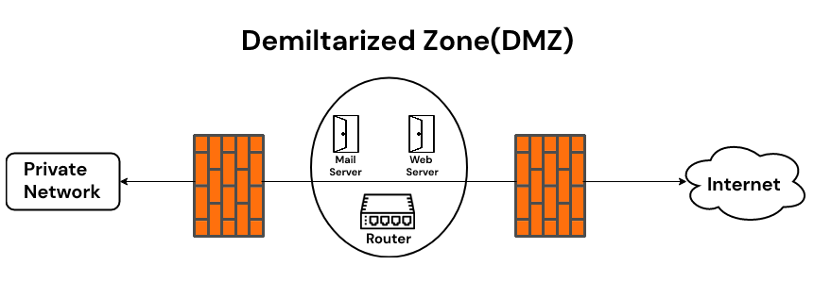

Opening Ports using DMZ
In the context of opening ports, using a DMZ means directing all incoming traffic to a specific device on the network and allowing that device to listen for and accept connections on all ports. This can be useful if you have a device that needs to be publicly accessible and you want to allow it to receive incoming traffic on any port. For example, if you have a web server that you want to make publicly accessible, you might put it in the DMZ and open all ports to allow it to receive incoming traffic from the internet. This can be useful if you want to host a public-facing web server or other services that need to be accessible from the internet. It’s important to note that using a DMZ can also potentially expose your device to security risks, as it allows the device to potentially be accessed by any device on the internet and potentially exploited. Therefore, it’s important to be mindful of which devices you put in the DMZ and to take appropriate security measures to protect them.

Advantages
- Improved security: A DMZ allows external access to servers while still protecting the internal network from direct exposure to the Internet. This can help prevent unauthorized access to sensitive internal resources.
- Simplified network architecture: By separating external and internal servers into separate zones, it can make it easier to manage and maintain the network.
- Improved reliability: By isolating external servers from the internal network, it can help prevent disruptions to internal services due to external attacks or other issues.

Disadvantages
- Increased complexity: Implementing a DMZ requires additional network configuration and management, which can be complex and time-consuming.
- Increased cost: Setting up a DMZ requires additional hardware and software, which can increase the overall cost of the network.
- Limited flexibility: A DMZ can limit the ability to access certain internal resources from external locations. This can make it more difficult for users to access resources that are located on the internal network.

Conclusion
Overall, the use of a DMZ can offer a number of advantages for organizations that need to expose their internal servers to the Internet. However, it is important for organizations to carefully consider the potential disadvantages before implementing a DMZ. By weighing the pros and cons, organizations can make an informed decision about whether a DMZ is the right solution for their needs.

VPN stands for the Virtual Private Network. A virtual private network (VPN) is a technology that creates a safe and encrypted connection over a less secure network, such as the Internet. A Virtual Private Network is a way to extend a private network using a public network such as the Internet. The name only suggests that it is a Virtual “private network,i.e., a” i.e. user can be part of a local network sitting at a remote location. It makes use of tunneling protocols to establish a secure connection.
How does a VPN work?

Let us understand VPN with Let’s an example
Think of a situation where the corporate office of a bank is situated in Washington, USA. This office has a local network consisting of say 100 computers. Suppose other branches of the bank are in Mumbai, India, and Tokyo, Japan. The traditional method of establishing a secure connection between the head office and the the branch was to have a leased line between the branches and head office which was a very costly as well as troublesome job. VPN lets us overcome this issue in an effective manner.
The situation is described below
- All 100 hundred computers of the corporate office at Washington are connected to the VPN server(which is a well-configured server containing a public IP address and a switch to connect all computers present in the local network i.e. in US head office).
- The person sitting in the Mumbai office connects to The VPN server using a dial-up window and the VPN server returns an IP address that belongs to the series of IP addresses belonging to a local network of the corporate office.
- Thus person from the Mumbai branch becomes local to the head office and information can be shared securely over the public internet.
- So this is the intuitive way of extending the local network even across the geographical borders of the country.
VPN is well exploited all across the globe
We will explain to you with an example. Suppose we are using smartphones regularly. Spotify-a Swedish music app which is not active in India But we are making full use of it sitting in India. So how ?? VPN can be used to camouflage our geolocation.
- Suppose the Ip address is 101.22.23.3 which belongs to India. That’s why our device is not able to access the Spotify music app.
- But the magic begins when we used the Psiphon app which is an android app and is used to change the device IP address to the IP address of the location we want(say US where Spotify works in a seamless manner).
- The IP address is changed using VPN technology. Basically what happens is that your device will connect to a VPN server of the respective country that you have entered in your location textbox of the Psiphon app and now you will inherit a new IP from this server.
Now we typed “what is my IP address”? Amazingly the IP address changed to 45.79.66.125 which belongs to the USA And since Spotify works well in the US, so we can use it now being in India (virtually in the USA). Is not that good? obviously, it is very useful.
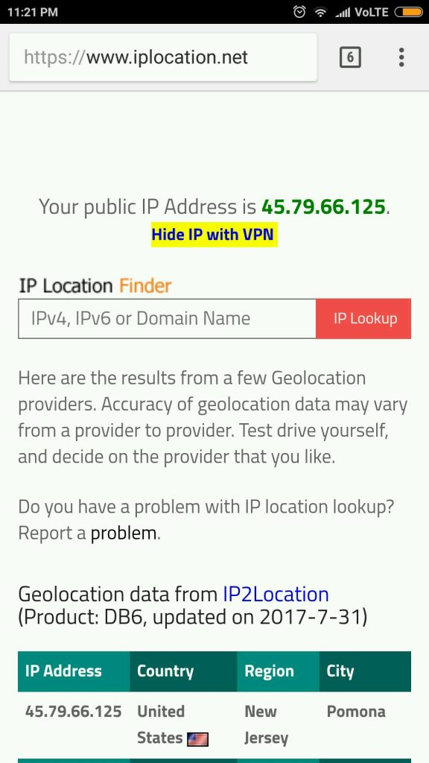
IP address changed to an IP address belonging to USA
- VPN also ensures security by providing an encrypted tunnel between client and VPN server.
- VPN is used to bypass many blocked sites.
- VPN facilitates Anonymous browsing by hiding your ip address.
- Also, most appropriate Search engine optimization(SEO) is done by analyzing the data from VPN providers which provide country-wise stats of browsing a particular product. This method of SEO is used widely my many internet marketing managers to form new strategies.
- VPNs encrypt your internet traffic, safeguarding your online activities from potential eavesdropping and cyber threats, thereby enhancing your privacy and data protection.

What is VPN used for?
Do you need help determining when you should use a VPN? Let us shed some light on the subject and show you how the best VPNs can revolutionize your online activities.
- For Unlimited Streaming: Love streaming your favourite shows and sports games? A VPN is your ultimate companion for unlocking streaming services like Netflix or Hulu. Access all the content you desire and never miss a moment of your beloved NFL games.
- For elevating your Gaming Experience: Unleash your gaming potential with the added layer of security and convenience provided by a VPN. Defend yourself against vengeful competitors aiming to disrupt your gameplay while improving your ping for smoother, lag-free sessions. Additionally, gain access to exclusive games that may be restricted in your region, opening up a world of endless gaming possibilities.
- For Anonymous Torrenting: When it comes to downloading copyrighted content through torrenting, it’s essential to keep your IP address hidden. A VPN can mask your identity and avoid potential exposure, ensuring a safe and private torrenting experience.
- For supercharging your Internet Speed: Are you tired of your Internet speed slowing down when downloading large files? Your Internet Service Provider (ISP) might be intentionally throttling your bandwidth. Thankfully, a VPN can rescue you by keeping your online activities anonymous, effectively preventing ISP throttling. Say goodbye to sluggish connections and embrace blazing-fast speeds.
- Securing Public Wi-Fi: VPNs are essential for maintaining security when using public Wi-Fi networks, such as those in coffee shops, airports, or hotels. These networks are often vulnerable to cyberattacks, and using a VPN encrypts your internet connection, protecting your data from potential hackers and eavesdroppers when you connect to untrusted Wi-Fi hotspots.

Are VPNs legal or illegal?
Using VPN is legal in most of the countries,. The legality of using a VPN service depends on the country and its geopolitical relations with another country as well. A reliable and secure VPN is always legal if you are not intended to use it for any illegal activities like committing fraud online, cyber theft, or in some countries downloading copyrighted content.
China has decided to block all VPN(Virtual private network)s by next year, as per the report of Bloomberg. Many Chinese Internet users use VPNs to privately access websites that are blocked under China’s so-called “great firewall”. This is done to avoid any information leakage to rival countries and so as to tighten the information security.
This article is contributed by Shivam Shukla. If you like GeeksforGeeks and would like to contribute, you can also write an article using write.geeksforgeeks.org or mail your article to review-team@geeksforgeeks.org. See your article appearing on the GeeksforGeeks main page and help other Geeks.
Please write comments if you find anything incorrect, or you want to share more information about the topic discussed above.

FAQs

Q1. Can a VPN Be Traced?
Answer:
While VPNs enhance privacy, it’s not entirely foolproof. In some cases, determined adversaries, such as government agencies, may employ advanced techniques to trace VPN usage. However, for typical online privacy needs, a VPN provides a high level of protection.

Q2. Do VPNs Slow Down Internet Speed?
Answer:
VPNs can introduce some degree of latency due to the encryption and routing processes. The extent of the speed reduction depends on various factors, including the VPN provider’s infrastructure, server location, and your internet connection. In many cases, the impact on speed is minimal, and modern VPN services strive to provide fast connections.

Q3. Are There Free VPNs?
Answer:
Yes, there are free VPN services available. However, they often come with limitations such as data caps, slower speeds, and less robust security features. Paid VPN services generally offer more reliable performance and better security.

Intrusion Detection System (IDS)

P
pp_pankaj

• Read
• Discuss
• Courses

A system called an intrusion detection system (IDS) observes network traffic for malicious transactions and sends immediate alerts when it is observed. It is software that checks a network or system for malicious activities or policy violations. Each illegal activity or violation is often recorded either centrally using a SIEM system or notified to an administration. IDS monitors a network or system for malicious activity and protects a computer network from unauthorized access from users, including perhaps insiders. The intrusion detector learning task is to build a predictive model (i.e. a classifier) capable of distinguishing between ‘bad connections’ (intrusion/attacks) and ‘good (normal) connections’.
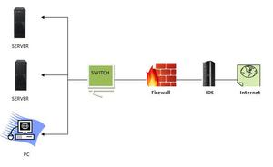

How does an IDS work?
- An IDS (Intrusion Detection System) monitors the traffic on a computer network to detect any suspicious activity.
- It analyzes the data flowing through the network to look for patterns and signs of abnormal behavior.
- The IDS compares the network activity to a set of predefined rules and patterns to identify any activity that might indicate an attack or intrusion.
- If the IDS detects something that matches one of these rules or patterns, it sends an alert to the system administrator.
- The system administrator can then investigate the alert and take action to prevent any damage or further intrusion.

Classification of Intrusion Detection System
IDS are classified into 5 types:
- Network Intrusion Detection System (NIDS): Network intrusion detection systems (NIDS) are set up at a planned point within the network to examine traffic from all devices on the network. It performs an observation of passing traffic on the entire subnet and matches the traffic that is passed on the subnets to the collection of known attacks. Once an attack is identified or abnormal behavior is observed, the alert can be sent to the administrator. An example of a NIDS is installing it on the subnet where firewalls are located in order to see if someone is trying to crack the firewall.
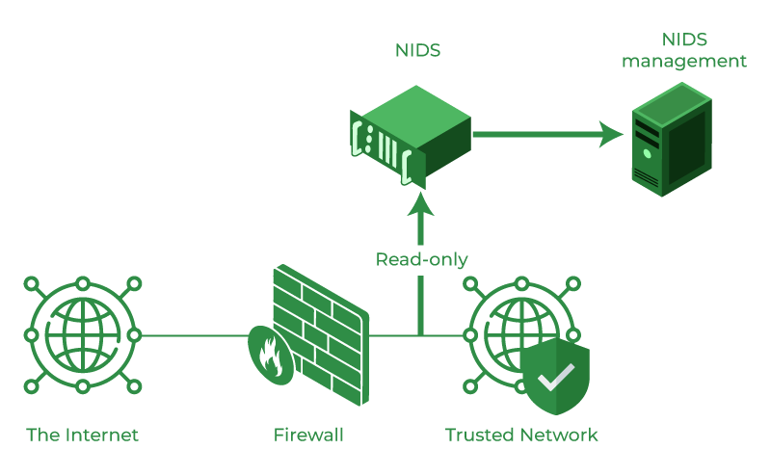

- Host Intrusion Detection System (HIDS): Host intrusion detection systems (HIDS) run on independent hosts or devices on the network. A HIDS monitors the incoming and outgoing packets from the device only and will alert the administrator if suspicious or malicious activity is detected. It takes a snapshot of existing system files and compares it with the previous snapshot. If the analytical system files were edited or deleted, an alert is sent to the administrator to investigate. An example of HIDS usage can be seen on mission-critical machines, which are not expected to change their layout.
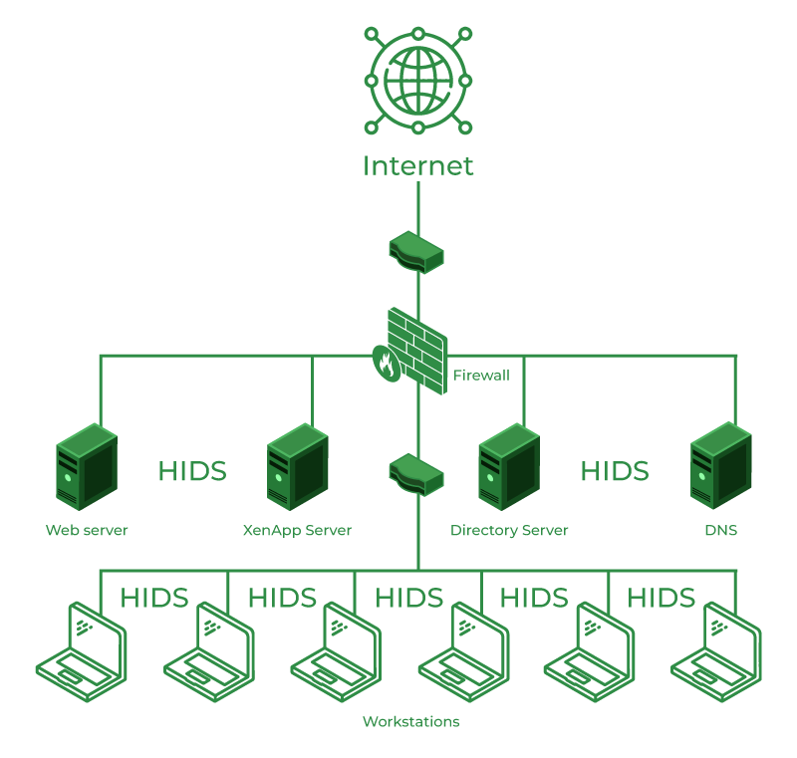

- Protocol-based Intrusion Detection System (PIDS): Protocol-based intrusion detection system (PIDS) comprises a system or agent that would consistently reside at the front end of a server, controlling and interpreting the protocol between a user/device and the server. It is trying to secure the web server by regularly monitoring the HTTPS protocol stream and accepting the related HTTP protocol. As HTTPS is unencrypted and before instantly entering its web presentation layer then this system would need to reside in this interface, between to use the HTTPS.
- Application Protocol-based Intrusion Detection System (APIDS): An application Protocol-based Intrusion Detection System (APIDS) is a system or agent that generally resides within a group of servers. It identifies the intrusions by monitoring and interpreting the communication on application-specific protocols. For example, this would monitor the SQL protocol explicitly to the middleware as it transacts with the database in the web server.
- Hybrid Intrusion Detection System: Hybrid intrusion detection system is made by the combination of two or more approaches to the intrusion detection system. In the hybrid intrusion detection system, the host agent or system data is combined with network information to develop a complete view of the network system. The hybrid intrusion detection system is more effective in comparison to the other intrusion detection system. Prelude is an example of Hybrid IDS.

Benefits of IDS
- Detects malicious activity: IDS can detect any suspicious activities and alert the system administrator before any significant damage is done.
- Improves network performance: IDS can identify any performance issues on the network, which can be addressed to improve network performance.
- Compliance requirements: IDS can help in meeting compliance requirements by monitoring network activity and generating reports.
- Provides insights: IDS generates valuable insights into network traffic, which can be used to identify any weaknesses and improve network security.

Detection Method of IDS
- Signature-based Method: Signature-based IDS detects the attacks on the basis of the specific patterns such as the number of bytes or a number of 1s or the number of 0s in the network traffic. It also detects on the basis of the already known malicious instruction sequence that is used by the malware. The detected patterns in the IDS are known as signatures. Signature-based IDS can easily detect the attacks whose pattern (signature) already exists in the system but it is quite difficult to detect new malware attacks as their pattern (signature) is not known.
- Anomaly-based Method: Anomaly-based IDS was introduced to detect unknown malware attacks as new malware is developed rapidly. In anomaly-based IDS there is the use of machine learning to create a trustful activity model and anything coming is compared with that model and it is declared suspicious if it is not found in the model. The machine learning-based method has a better-generalized property in comparison to signature-based IDS as these models can be trained according to the applications and hardware configurations.

Comparison of IDS with Firewalls
IDS and firewall both are related to network security but an IDS differs from a firewall as a firewall looks outwardly for intrusions in order to stop them from happening. Firewalls restrict access between networks to prevent intrusion and if an attack is from inside the network it doesn’t signal. An IDS describes a suspected intrusion once it has happened and then signals an alarm.
Conclusion:
Intrusion Detection System (IDS) is a powerful tool that can help businesses in detecting and prevent unauthorized access to their network. By analyzing network traffic patterns, IDS can identify any suspicious activities and alert the system administrator. IDS can be a valuable addition to any organization’s security infrastructure, providing insights and improving network performance.

